SHOALHAVEN CITY COUNCIL
December 2023
Abstract
The purpose of this plan is to provide an appropriate management framework and site-specific procedures for the Resource Recovery Learning Centre, in line with the required environmental, social and WHS outcomes.
This plan addresses specific requests made by DA Officer Rebecca Lockhart on 18/10/2023 in support of RA23/1004.
Resource recovery learning centre
OPERATIONAL MANAGEMENT PLAN

Version Control
Version | Change from previous | Date | Comment
DRAFT | Document prepared in accordance with request made by DA officer Rebecca Lockhart on18/10/2023 | 24/10/2023
DA ISSUE | Document submitted to the Planning Portal | 07/12/2023

Plan Approval
Name | Position | Date | Signature
Darron Ellery | Manager – Waste Services | 06.12.2023
Fiona Schreurs | Resource Recovery Project Coordinator | 06.12.2023

Contents
1 Introduction 1
1.1 General 1
1.2 Objectives 1
2 Operations 3
2.1 Intended Users 3
2.2 Bookings 3
2.3 Activities 3
2.4 Hours of Operation 3
2.5 Access & Site security 4
2.6 Pedestrian traffic management 4
2.7 Utilities 5
2.8 Operation and compliance of kitchen areas 5
2.9 Operational and environmental management 6
2.10 Emergency Procedures 6
3 Document Management 7
3.1 Review 7

Introduction

General
The facility proposes to create a professional, engaging, tactile space for community learning and awareness-raising around waste and sustainability.
Proposed operations include offering community workshops on practical ways community members can implement behaviour change and lifestyle improvements around waste reduction, waste avoidance and sustainability.
All aspects of waste avoidance and reduction practiced at the West Nowra Recycling and Waste Depot, will be demonstrated and modelled.
School groups will be offered age-appropriate activities including learning through play (eg Mini Materials Recovery Facility or “MRF”) and practical applications (eg composting, worm farming, veggie gardening).
The facility will provide office and meeting room spaces to support Waste Services Staff.
This plan applies to the Resource Recovery Learning Centre (hereafter referred to as the RRLC) situated in the West Nowra Recycling and Waste Facility (depot) on Flatrock Road.

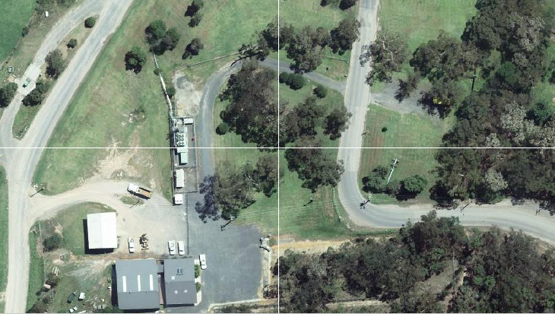

Objectives

Shoalhaven City Council’s vision for waste management is stated in its Waste Reduction Management Strategy 2022 - 2027:
“to reduce waste generation, maximise recovery and minimise disposal”
The RRLC aligns with this vision by providing a platform to raise public awareness of waste management.

The objectives of this OMP are to:
- Describe the activities and services delivered by the building
- Describe the hours of operation and booking systems for the building
- Describe the security and access to the site, including pedestrian and vehicle movement
- Describe the utilities supporting the building
- Describe the emergency procedures for staff and visitors to the building.

Operations

Intended Users
The intended visitors comprise all residents of the Shoalhaven, including social, recreational, environmental, professional and cultural groups, and School groups from Pre-school through to Senior school students. The RRLC will also be used by council staff for training and meetings.
The facility will also offer dedicated office and meeting spaces for Waste Services staff.

Bookings
People are encouraged to book their visit by telephone and on-line via the Shoalhaven City Council website.

Activities
The RRLC will act as a hub for:
- Waste Depot Tours conducted by Council staff;
- Community information sessions/presentations around the on-site landfill and resource recovery operations;
- Kerbside recycling talks;
- A range of Home Sustainability Workshops for both children and adults;
- Outdoor workshops including composting and worm farming, undertaken in the Outdoor Learning Space; and
- Office and meeting spaces for Waste Services Staff.
The RRLC will provide a showcase space for artists who use recovered or recycled materials in their artworks or sculptures on a rotating basis. This will be housed in the Front of House space.
Additionally, the entry pavilion will house wall-mounted computer monitors conveying real-time operations from around the West Nowra site eg: recyclate sorting inside the MRF, operations inside the glass processing shed and other operations where appropriate.

Hours of Operation

The whole West Nowra site is open between 8am to 5pm, 7 days a week. The RRLC will be open for public activities within these hours.
Occasional evening educational workshops will be offered.

Access & Site security

The building is sited within the West Nowra Recycling and Waste Depot.

During operating hours, The Flatrock Road main entrance gate is open to the public. All other access gates to the depot are not for public access and are always closed unless used by SCC staff for operational purposes.

Outside operating hours, the main entrance and other access gates will be locked, and SCC will maintain the security of the Facility.

The depot boundary is enclosed by 1.8m and 2.1m high security fences. Depot staff will continue to maintain the following security measures:
- The RRLC will be locked outside operating hours;
- Keys to gates and buildings will be kept only by necessary SCC site staff members;
- The gates and surrounding fence areas are inspected daily;
- The boundary fence line is inspected weekly and on an as needs basis.

In addition to the West Nowra Recycling and Waste Depot access and site security, the RRLC will have lighting, door locks, alarms and security cameras fitted where appropriate.

Pedestrian traffic management
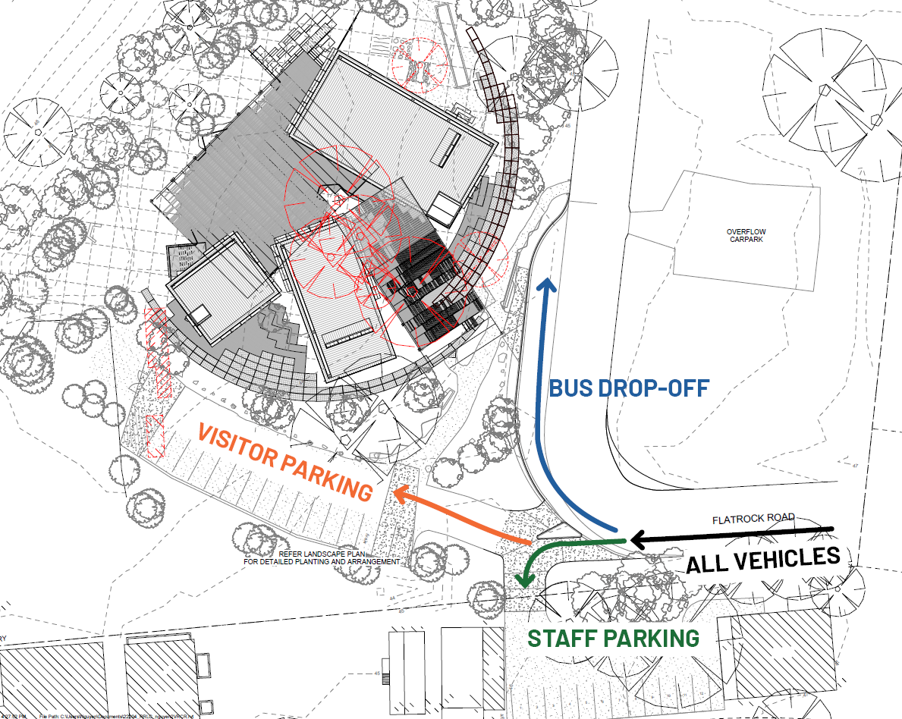
The above diagram demonstrates the use of existing parking for staff, the new visitor parking on-site and the adjacent bus drop-off area on the same site. Overflow parking is also an option if staff and visitor parking has reached full capacity.
Carparks are located next to the buildings on the southern side for visitors. Staff access to Office Pavilion directly from carpark via the doorway.
Visitor access via a pathway skirting the building to the front door.
Buses load/unload passengers in Bus Bay, which has direct access to the front door.
There will be no pedestrian movement across the roads.
Loading and Waste Management for the RRLC is accessed through the carpark to the rear of the Office Pavilion.

The loading and waste management shares the same access as the visitor carpark. Loading and waste management duties will be performed outside of visitor hours to limit crossover and any potential dangers to visitors.

Utilities

Stormwater
The RRLC uses the existing open trunk drain pit as part of an integrated swale system across the site. This includes the carpark which features a new integrated swale that collects water into the expanded low point on site in which all water flow will be directed to for retention and future stormwater treatment for reuse through two treatment processes.

Wastewater
It is proposed to primary treat all wastewater generated on-site via a NSW Health accredited 5.0KL septic tank system. This will address the anticipated wastewater loading rates (approximately 1,290L / day). Treated wastewater is to be stored in a collection well, with collection to be arranged via a cartage contractor. De-sludging of the septic tank is to occur at a min. 5 year frequency.

Water supply
The water supply shall be taken from the existing incoming potable water supply located on Flatrock Rd. The water supply will be metered to enable recording of centre usage.

Power
Power to the site shall be taken from the existing incoming aerial supply. A separate switchboard with separate metering will be established for the learning centre.

Communications
NBN does not currently service this area with underground cabling. The most likely connection will be via fixed wireless. This will be determined once the client applies for communications services.

Operation and compliance of kitchen areas
The kitchen space in the Multi-purpose Hall is for demonstration classes only. No grease trap will be necessary and will be a reheat kitchen providing tea and coffee.
The kitchenette in the office space will be identical in nature with the allowance for a microwave for food reheating.
Kitchen space will be built to relevant building codes and incorporate industry standard hazard reduction equipment/measures.

Operational and environmental management

Council’s Landfill Environmental Management Plan (LEMP) dated 2019 outlines control measures and procedures to manage nuisance, dust, litter, erosion and sedimentation, vegetation, noise, water quality, disease vectors, odour, pest species and fire prevention. This plan applies to the Facility as a whole and is updated periodically to ensure compliance with regulatory controls such as the EPL and Environmental Guidelines for Solid Waste Landfills.

Emergency Procedures

The building is sited within the West Nowra Recycling and Waste Depot.
In addition to the West Nowra site emergency procedures, the RRLC will have clearly defined emergency procedures, including site evacuation diagrams, located on wall spaces as appropriate. Fire extinguishers and Fire blankets will be located within the buildings as appropriate.

Council will ensure the RRLC is appropriately staffed by trained, competent and experienced personnel. A minimum of one staff member will attend the RRLC during its operational hours.

Council will take all necessary precautions to ensure the safety of all staff, contractors and visitors at the RRLC.

Council will provide and maintain first aid treatment facilities at the RRLC and will have a trained first aid officer on site during operating hours.

Council staff will be familiar with, and able to readily carry out, their required duties in accordance with all relevant Workplace Health and Safety (WHS) regulations and guidelines.

Document Management

Review
The period for review will be 3 years.
The officer responsible for this document is the Asset Custodian (Waste Services Manager).

